**Analyze Change Request**

**Module Description**

Now that the details of the Change Request have been considered, this is your opportunity to discuss its impact and the potential solutions.

**Scenario**

The Team Lead will assist you and your team to perform an impact analysis on each change request. The Team Lead will help your team:

* Determine the impact of the change, using the RTM and other work products.
* Formalize solution options.
* Determine what code/documents/test deliverables must be updated for each solution.
* Derive estimates on how long it would take for the fix to meet the new/changed requirements.

You will look at each change request (CR) and:

* Conduct an impact analysis with your team to see what options are there to implement the CR.
* Determine which specific objects/documents are affected.
* Determine what work product updates are required and then assess which option is best.

**ADM Activity Context Diagram**

**High Level Context Diagram**

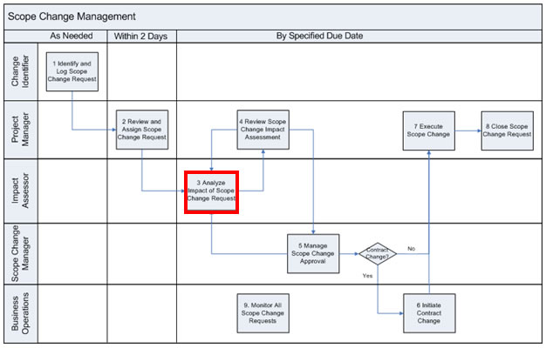

**Low Level Context Diagram**

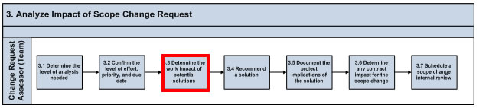

**Roles**

|  |  |  |  |
| --- | --- | --- | --- |
| **Role** | **ADM Task** | **ADM Responsibility** | **Description** |
| Manager | N/A | Management Oversight | Provides guidance on analysing the change requests. |
| Team Lead | N/A | Primary Performer | Makes decisions on which solution option(s) will be used for each Change Request. |
| Team (All) | N/A | Primary Performer | Prepares solution options for each Change Request and performs an impact analysis for each option. |

**Participant Instructions**

1. Perform a complete detailed analysis of the scope change request:

a. Review the [AP201 - Requirements and Traceability Document](https://accenture.desire2learn.com/content/enforced/9406-Pending/NCCC_Project_Work_Products/3a_App_Analysis/Release_1/RTM_FERS_R1_REF.xlsx?_&d2lSessionVal=YnoL4daZGC8ne2RyGf0cWMrk8) to determine what requirements are affected (if any).

b. Review each document associated with the affected requirements from the *NCCC Project Work Products* section on the site and estimate the effort to update each document.

c. For any new requirements, consider the effort involved in creating new deliverables or updating existing deliverables.

2. Consider different solution options for each scope change request.

3. Determine the impact and the effort of each alternative, including:

a. Effort to develop new and update existing application code

b. Effort to test the code changes

4. Consult with other team members as needed to obtain the relevant information.

5. Document any initial updates/ideas in the Change Request document.

**Note:** Do **NOT** attempt to fully complete the CR tracker at this point. Just consider the different approaches to address and implement each of the CRs and their resulting impact.

**Hints and Tips**

When estimating impact, use the following guidelines (please note a number of estimating factors go into determining effort-these numbers are used as an example for demonstration purposes only):

* Updating existing work products: (Technical/Functional Design)
  + Very complex: 12 hrs
  + Complex: 4 hrs
  + Medium: 2hrs
  + Simple: 1 hr
* Creating new work products: (Technical/Functional Design)
  + Very complex: 24 hrs
  + Complex: 8 hrs
  + Medium: 4 hrs
  + Simple: 2 hrs
* Code Development (Build/Unit Test) per class
  + Very complex: 24 hrs
  + Complex: 16 hrs
  + Medium: 8 hrs
  + Simple: 4 hr
* Application Test (Assembly/Product)
  + Very complex: 24 hrs
  + Complex: 16 hrs
  + Medium: 8 hrs
  + Simple: 4 hr

Keep in mind that hours represented are total person hours. For example, if 3 developers are involved in Build/Unit test of a very complex module then it could take 8 hours (if all the work can be done in parallel:

equation